DATA ANALYTICS CASE STUDY

Walmart Time Inventory Optimization Report

Presented BY
JAYA SUHANE| JOB AAJ |03/03/2025

Problem
Walmart faces inventory management challenges, struggling to balance stockouts and overstocking. The problem requires a data-driven solution that dynamically adjusts inventory levels by forecasting demand based on past sales and real-time insights.

Background
Walmart faces inventory management challenges due to fluctuating demand, promotions, and external factors like weather. The operations team must balance stock levels to avoid overstocking and stockouts while maintaining efficiency.

Solution
Walmart plans to enhance inventory management by implementing real-time demand forecasting through the analysis of historical sales data. This involves examining customer purchasing patterns, external factors like weather, and the impact of promotions to inform inventory decisions, streamline operations, reduce costs, and boost customer satisfaction.
The project will follow an Agile methodology, dividing work into sprints—short, time-boxed periods focused on specific tasks—to allow for continuous value delivery and adaptability based on insights gained during the process.
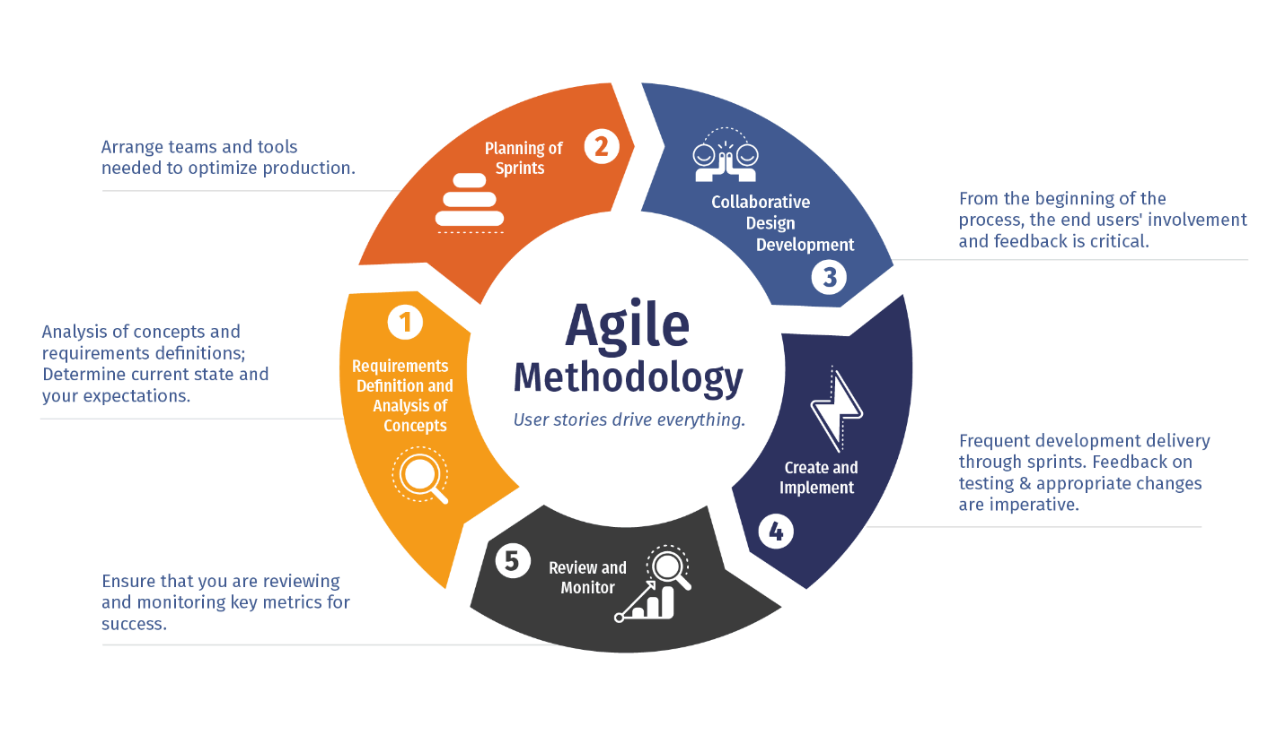

Methodology And Project Scope
The project scope for Walmart's real-time demand forecasting initiative encompasses several key components:
- Data Collection and Integration:
  - Gather historical sales data, customer purchasing patterns, promotional impacts, and external factors such as weather.
  - Integrate data from various sources to create a comprehensive dataset for analysis.
- Demand Forecasting Model Development:
  - Develop predictive models using machine learning algorithms to forecast demand accurately.
  - Incorporate factors like seasonality, market trends, and external influences to enhance model precision.
  - implement systems to process and analyse data in real-time, allowing for immediate insights and decision-making.
  - Utilize demand sensing techniques to quickly detect short-term market changes and adjust inventory strategies accordingly.
- Agile Project Management:
  - Adopt an Agile methodology, dividing the project into sprints to facilitate continuous value delivery and adaptability.
Agile Methodology Implementation
● Sprint 1: Data Collection and Cleaning
○ Conduct initial exploratory data analysis (EDA) to identify data patterns, clean missing values, and ensure data consistency.
○ Collaborate with stakeholders (inventory managers and store managers) to
define key metrics for the analysis.

● Sprint 2: Exploratory Data Analysis and Initial Forecast
○ Analyse customer buying patterns, weather impact, and promotional
effectiveness using various data techniques.
○ Present preliminary insights in a sprint review to gather feedback from
stakeholders.

● Sprint 3: Refining Insights and Developing Forecasts
○ Build a detailed analysis report with advanced forecasting models.
○ Focus on optimizing inventory levels based on projected demand patterns.
● Sprint 4: Insights Presentation and Actionable Recommendations
○ Present the final analysis and recommendations to key stakeholders in a
sprint review meeting.
○ Document all findings, ensuring alignment with business goals and real-time decision-making processes.
Stack Holder Involvement
Internal Stakeholders:
○ Inventory Managers: Will use the demand forecasting insights to ensure
optimal stock levels across stores.
○ Store Managers: Responsible for managing in-store inventory based on
demand.
○ Marketing Team: Understands how promotions impact sales and tailors
campaigns accordingly.
External Stakeholders:
○ Customers: Their purchasing behavior directly influences demand forecasts.
○ Suppliers: Will receive more accurate forecasts to ensure timely and
sufficient product delivery.

- Actionable Insights and Recommendations:
  - Analyse the data to uncover patterns and trends that inform inventory decisions.
  - Provide actionable recommendations to streamline operations, reduce costs, and enhance customer satisfaction.
- Performance Monitoring and Optimization:
  - Establish key performance indicators (KPIs) to monitor the effectiveness of the demand forecasting models.
  - Continuously refine models and strategies based on performance data to ensure ongoing improvement.
Goals And KPI’s
Goals
    - Walmart using a data-driven inventory optimization solution that minimizes both stockouts and overstocking by forecasting demand based on past sales data.
2. For maximizing both revenue and customer satisfaction, Walmart
focus on profitability strategies for low-margin products,redictive modelling for future promotions, store-level customization of inventory, and data-driven strategies for future promotions.

- Allow Walmart to optimize inventory for new stores,
- handle seasonal demand fluctuations
- prioritize high-demand products for peak seasons
- ensuring stock availability at the right times.
KPI’s
- The total sales volume across all Walmart stores:14914
- The average unit price of all products sold, by category:
Appliances | 1023.381503
Electronics | 1023.547443
Grand Total 1023.467294
- Stores which is underperforming in terms of sales volume is: Miami , FL.
- The total revenue generated from sales during promotional events
15263601.45

- Product categories see the largest increase in demand during holidays
Electronics

Concept Used
To address inventory management challenges arising from fluctuating demand, promotions, and external factors like weather, Walmart can implement demand forecasting and inventory optimization strategies.
Demand Forecasting involves predicting future customer demand by analysing historical sales data, customer purchasing patterns, and external influences such as weather and promotional activities. Accurate demand forecasting enables Walmart to anticipate customer needs, thereby reducing the likelihood of stockouts and overstock situations.
Inventory Optimization focuses on maintaining the ideal balance between having sufficient stock to meet customer demand and minimizing holding costs. This process includes setting appropriate safety stock levels, determining optimal reorder points, and employing strategies like Just-in-Time inventory management to enhance efficiency.
Conclusion
By integrating above concepts, Walmart can dynamically adjust inventory levels in response to real-time insights, streamline operations, reduce costs, and improve customer satisfaction.
THANK YOU
For Any QUERY CONTACT US on

S suhane79jaya@gmail.com

https://www.linkedin.com/in/jaya-suhane-776142275/

peerlist.io/jayasuhane/

